**Lab Task 1**:

Related to Components and calling of components using useStates on button

Create your react app using the concept of “**Components in Components**”, create one component “List of Pakistan Provinces”, and another component having “List of Capitals of each Provinces”. Create the third component to display these two lists.

**Note:** The third components should contain only headings text, like i.e. “Provinces of Pakistan are:”. But theses components run through button press.

In this you need to create three components Capitals.js , Provice.js & display.js and call these components in display and display call in the App.js file

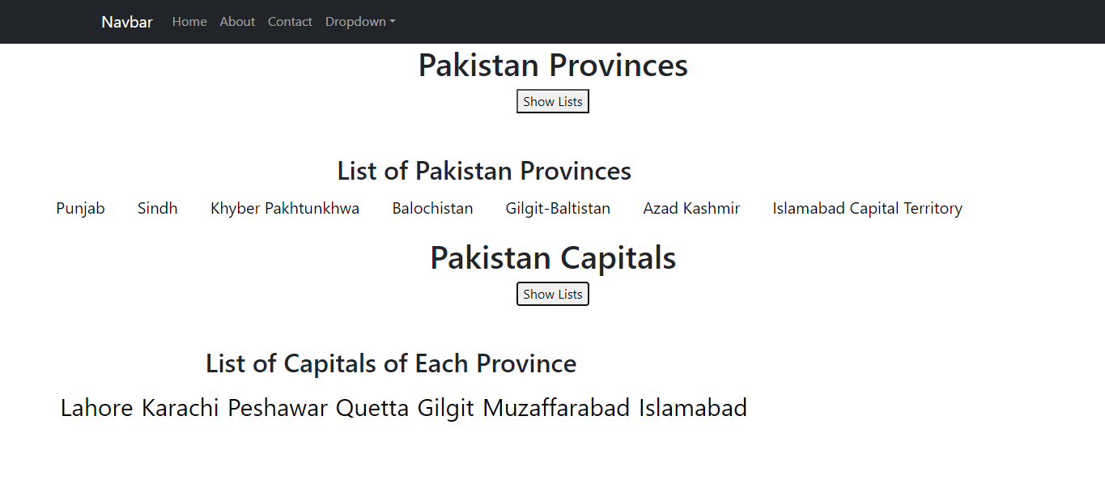

**Paste Your Code and Screenshot of your project Here**

**Lab Task 2**:

Related to Props

Create your react app using the concept of “**Components in Components and props**”, create one component having “Capital of Country” using props. Create a component to display this component for “Pakistan, Islamabad”, “India, Delhi” and “Tukey, Ankara”.

**Paste Your Code and Screenshot of your project Here**

**Lab Task 3:** Get started with “React”, create your react app and Design a page given below.

Instructions:- Make 4 components NAV , Profile , Signup , Footer these are the functional components use these components in the App.js folder make one separate css file for login page and rest of style apply through App.css file use the Assets folder of images.

For Nav use the <Link to = “/”></Link> tag of react through react-router-dom package.

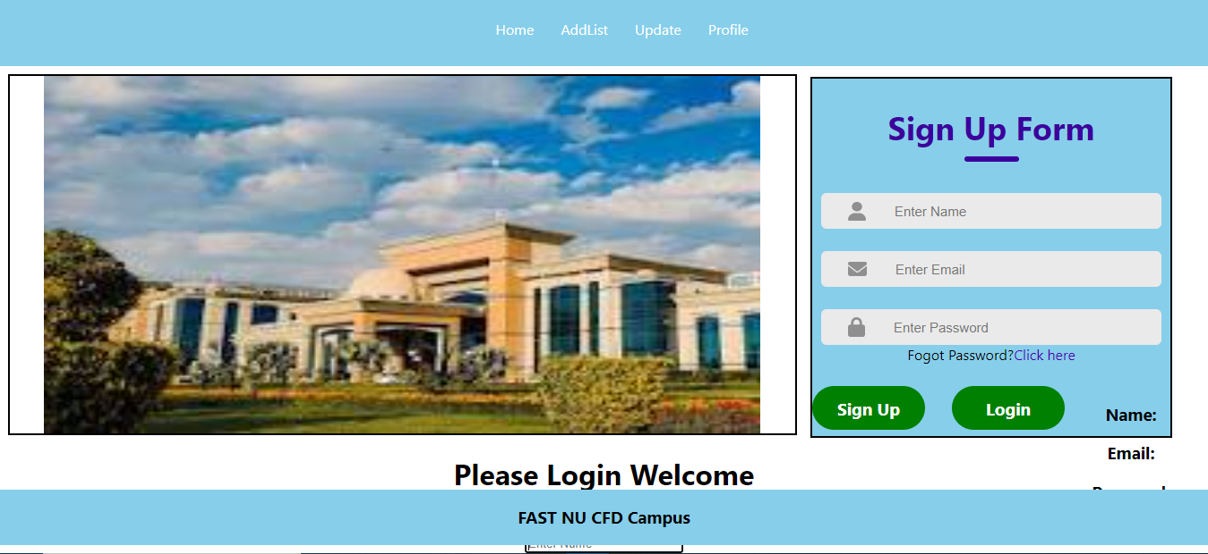

QNO4:- Consider the QNO1 just modify to display the values which you will be entered display these values like name email and password are displayed using state variables and onChange method use

Routing Add in this Program like when click on the AddList button then display only one form which is Addproductform with same styling.